Paralyzed designer creates jeans for women in wheelchairs

BY [HAYLEY WILBUR](https://mashable.com/author/hayley-wilbur/)AUG 20, 2015

Most pieces of clothing are not designed for people with disabilities. Alter Ur Ego is not one of them.

Heidi McKenzie, a T4 paraplegic woman paralyzed in a car accident in 2007 at the age of 21, has designed a collection of jeans dubbed [Alter Ur Ego](http://alterurego.co/) for people who use wheelchairs.

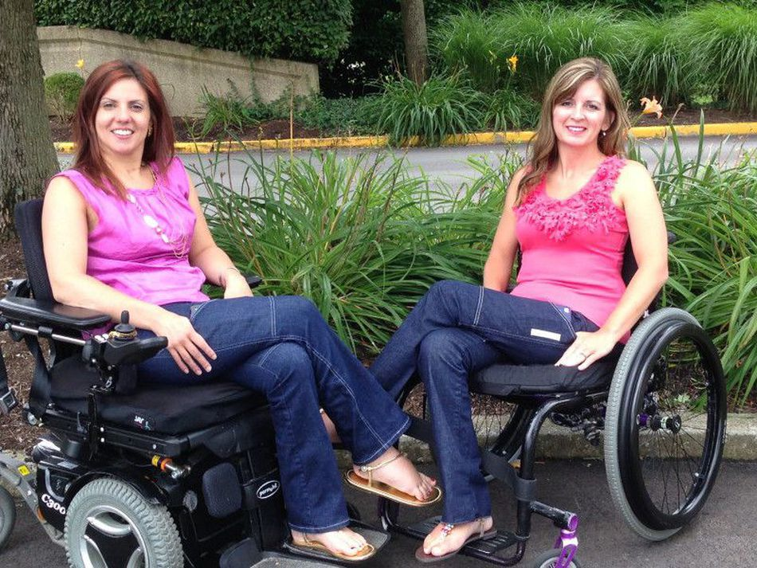

After participating in Ms. Wheelchair Kentucky 2012, McKenzie realized she was not the only woman experiencing difficulty finding fashionable yet adaptable clothing that fits a seated body.

So, the 29-year-old Kentucky native teamed up with designer Kristin Alexandra Tidwell to create a comfortable, functional pair of jeans.

The jeans retail at $80 each and are designed for both men and women. They are made with Spandex and include large side pockets for easy access, a high-waisted back, a tummy control panel and a catheter opening.

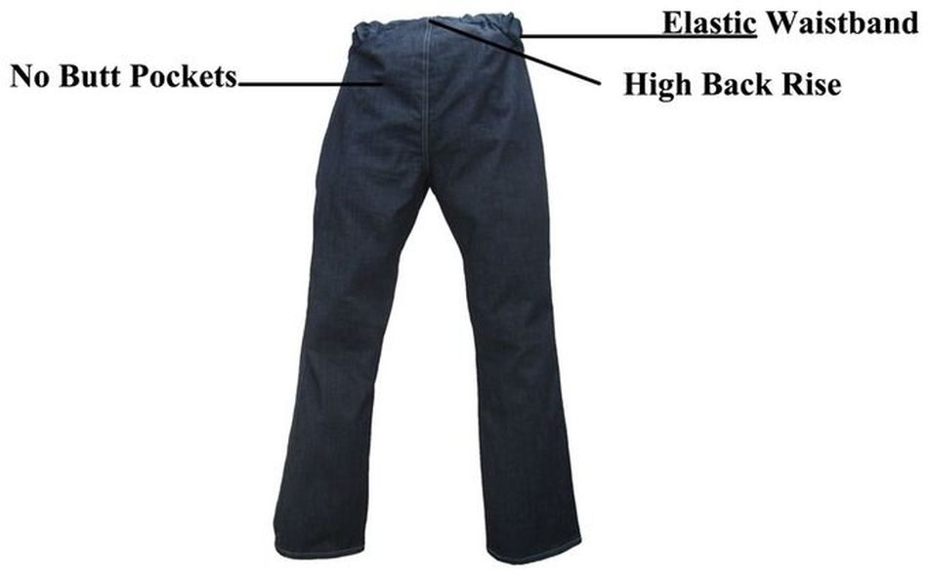

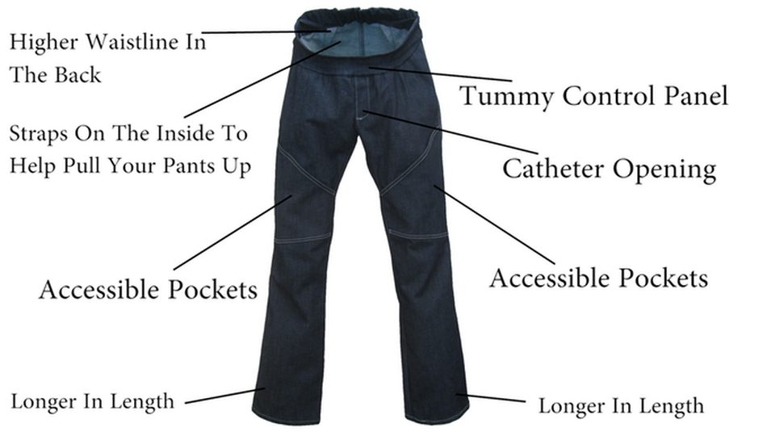

Currently on [Kickstarter](https://www.kickstarter.com/projects/23821314/alter-ur-ego-wheelchair-fashion-made-in-the-usa/description), the product has earned $10,309 at the time of writing, with an initial goal of $20,000. The campaign has nine days left before expiration.

When shopping for pants, McKenzie always had to look for something that fit high on the waist. For disabled people, most pairs drape towards the back, are hard to get on and off, cut into your hips and/or have useless front and back pockets.

Her plans to work in fashion paused after her accident but restarted after she graduated from a small business program and took an accelerated "how to start a clothing line" program.

"I originally wanted to have a retail store, but once I figured I could make a difference firsthand with being in a wheelchair and design adaptable clothing, I was determined to do it," McKenzie tells *Mashable*. "Most adaptable clothing is targeted towards the elderly, and I wanted something fashionable that everyone would be able to express their alter ego through their fashion."

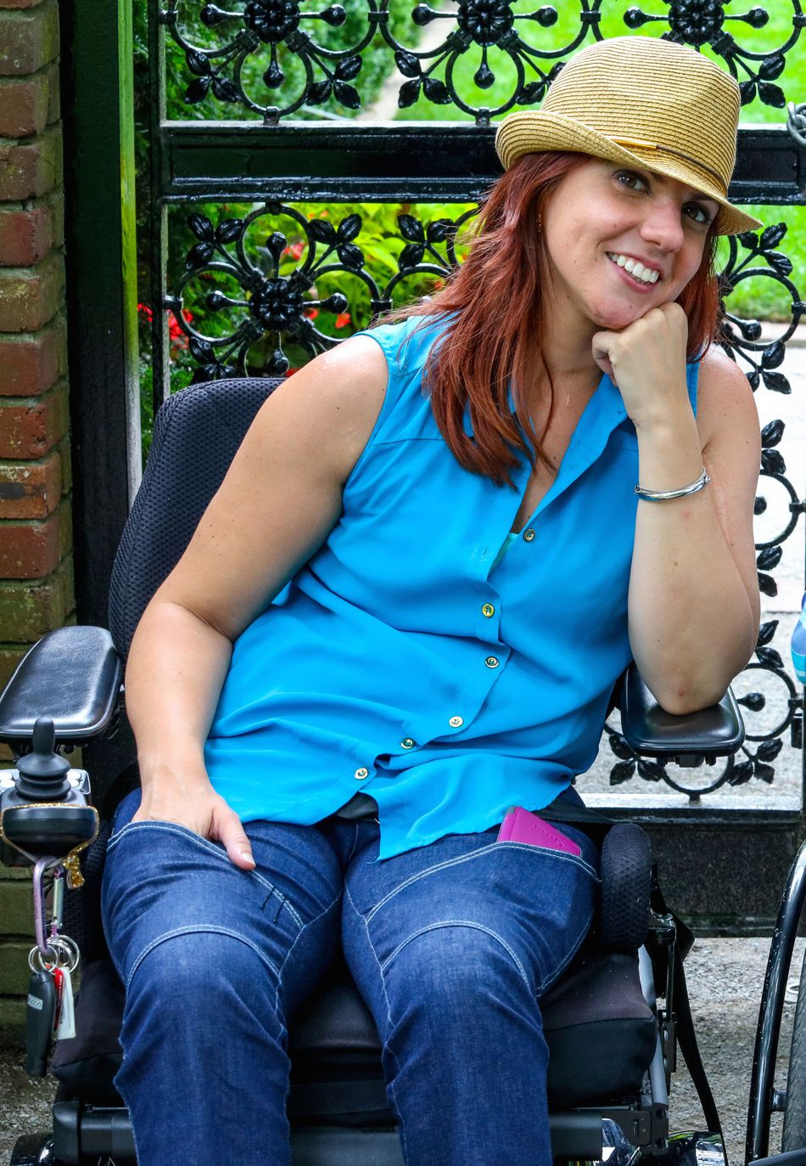

McKenzie has received many positive reactions from people who use wheelchairs.

"It's mainly a feeling of confidence in knowing that these jeans were made for someone in a wheelchair and they’re fashionable, so a lot of people will notice the pockets right on the side," she explains. "I’ve had some people [who aren't in a wheelchair] comment, 'I want some of those' or those that are say, "I haven't worn jeans in X amount of years because I can't find one that will work for me."

McKenzie, through Alter Ur Ego, plans to expand and create a sustainable clothing line of items ranging from blouses, dresses and jackets, to give people more independence.

"I hope that it gives them confidence and breaks down social barriers.”